SIP-Applet
Architecture specification
Authors: Risto Känsäkoski State: Draft/Proposal/Approved
Version: 1.0 Date: 29.5.2009 Approved by: Johan Sjöblom
Security classification: Public/Confidential/Secret
Version History
Version Changes Author Date
0.1 Initial Draft Risto Känsäkoski 8.4.2009
1.0 Approved Risto Känsäkoski 29.4.2009
1.1 Small corrections Risto Känsäkoski 5.8.2009

Table of contents
Introduction 3
Architecture overview 3
Deployment 4
Architecture evaluation 4

Introduction
This document describes the architecture used in SIP Applet

Architecture overview
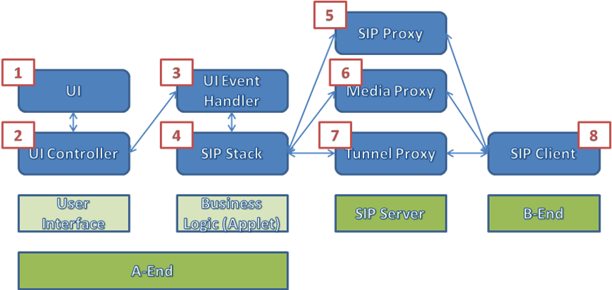
Picture 1. Component view
- HTML user interface (a www page). The UI can be fully customized.
- Java Script UI Controller. The UIC links business logic and UI together. It forwards user actions to business logic and informs UI about events in business logic.
- UI Event Handler is interface to business logic for UI Controller. It is written in Java.
- SIP Stack is based on MjSip (http://www.mjsip.org/) which is an open source Java implementation of SIP. It is responsible of all communication between Applet and SIP Server/B-End.
- SIP Proxy handles SIP signaling and maintains SIP sessions.
- Media Proxy is a (optional) component of SIP Server which allows transferring media to clients behind NATs.
- Tunnel Proxy is used to bypass firewalls. It masks SIP and RTP traffic to look like normal HTTP-traffic. SIP Applet supports HTproxy’s (http://www.mbdsys.com/opensource/htproxy/) tunneling protocol.
- B-End

Deployment
To take advantage of SIP Applet [3]+[4], a SIP operator needs www server supporting applets (for example Apache), an HTML page implementing UI Controller/UI interface [1]<->[2], and a SIP Server (for example OpenSIPS). The HTML page and Applet are deployed in the www server. The HTML page must include JavaScript libraries from [2]. The SIP Server must include at least a SIP Proxy [5] and can also include a Media Proxy [6] and a Tunnel Proxy [7]. If conversation between two clients is wanted, another SIP client is needed at the B-End [8].
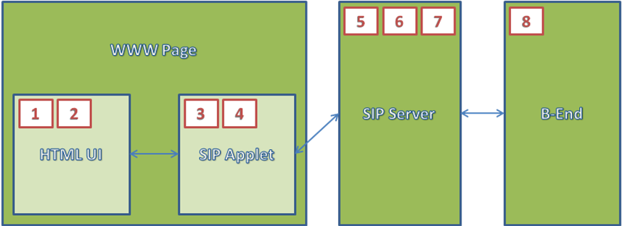
Picture 2. Service view

Architecture evaluation
The architecture can be evaluated without setting up a SIP server. If an existing SIP account is available, acquire one free account from iDIal web service (http://www.idial.fi/). If no existing accounts are available, acquire two iDial accounts. Two user agents are also needed. In the A-End use the SIP Applet. SIP Applet can also be used in the B-End, but any software or hardware user agent is sufficient.
Latest SIP Applet build with very simple reference UI is located in the project’s “deploy” folder. You should now have two accounts and two user agents, one each for A-End and one each for B-End. To start the SIP applet, open idial.html or index.html in a web browser. Idial.html is preconfigured for use with iDial account, though one parameter has to be set manually. You must set codebaseUrl parameter to point the location of the applet’s jar file. Example:
<param name="codebaseUrl" value="file:///C:/SIP-Applet/deploy/" />
If you want to use other SIP service than iDial with the SIP Applet, you have to set correct parameters in index.html, but that is not in scope of this document.

